1. **Chapter: Documents**
   1. *The essence of Software Engineering is to construct documents based on a context of people and the further environment in which this software is to be inserted.*
   2. *It is important that the Software Engineer is a literate person*
   3. Three kinds of documents:
      1. Text which **informs**, but **do not describe** that which the **phase of development** is to develop
      2. Text that describe/prescribe/specify that which the **phase of development** is to develop
      3. Text that analyze
      4. **A development document may contain all these parts, but they should be delineated and marked.**
2. **Information Vs Description Vs Analysis**
   1. **Describing/Prescribing:** Desginates and/or delineates some physically existing phenomenon or defines a concept which can be said to be an abstraction of physically existing phenomenon.

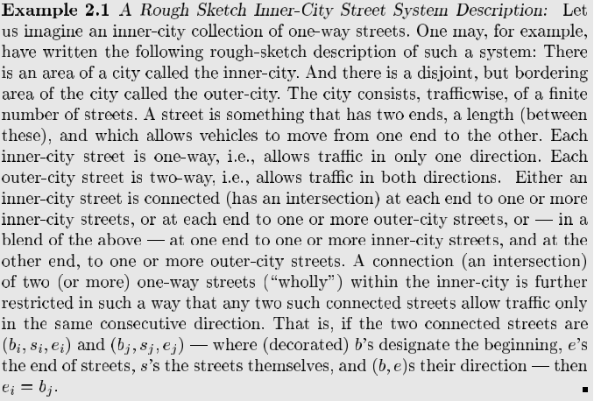

* 1. **Analyzing:** Proves or designates properties/rules of some other text, or properties that are claimed to hold between pairs of texts

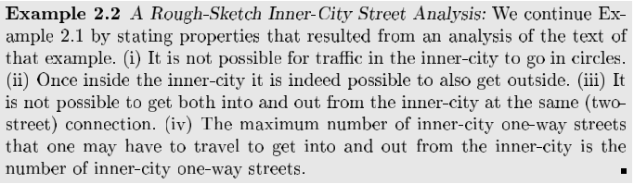

* 1. **Informing:** Text, which is neither basically descriptive nor analytic, in other words, a text which does not designate physical phenomena or concepts directly related to these, but a text which otherwise “points” to or implies descriptive or analytic documents. **Example of informative text that come before Descriptions and their Analysis:**
     1. **Kinds of Informative text:**
        1. Name, place and date
        2. Listing of partners
        3. Current Situation
        4. Needs
        5. Ideas
        6. Concepts
        7. Scope
        8. Span
        9. Synopsis
        10. Assumptions and Dependencies
        11. Implicit/Derivative goals
        12. Standards
        13. Contract
        14. Design Brief
        15. LogBook

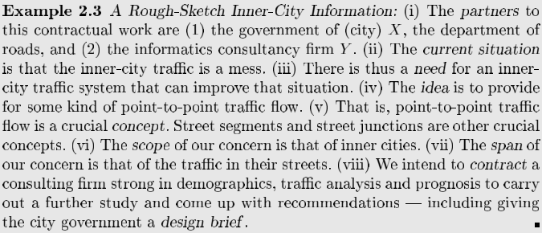

***\*\*****Domains are* ***described,*** *requirements are* ***prescribed,*** *and software is* ***specified\*\****

1. **Name, Place and Date:**
   1. Brief, Informative Name: eg. **Providing or Acquiring Domiciliary Services**
2. **Partners:**
   1. Clients: what enterprise, institution, or other client, that wish a problem to be investigated
   2. Advisors: consultancy firms
   3. Developers: